Test Number | Item Tested | Test Data | Expected Result | Actual Result | Fix
1 | btnGo,  calculating the cost | Click  From 23/03/2020  To  27/03/2020 | The total costs of each department within the date range are displayed on the DataGridView correctly. The table displayed should be exactly same as what the sample design shows. The department that spent least is at the top. The order is ascending. | 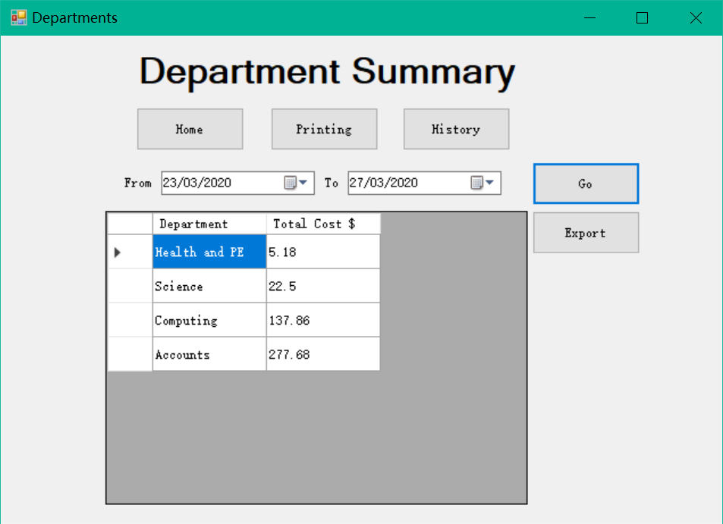 | No fix needed
2 | btnExport | Click  23/03/2020  To  27/03/2020 | A new csv file named “summary_26062020.csv” is created in the “bin/Debug” folder. It displays the same as displayed in the DataGridView. | 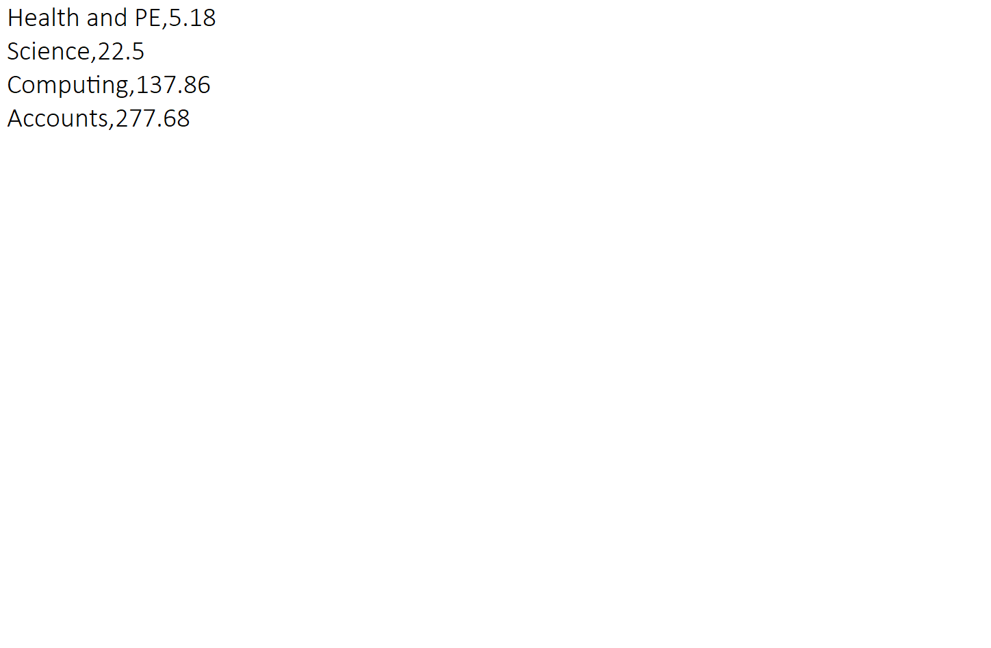  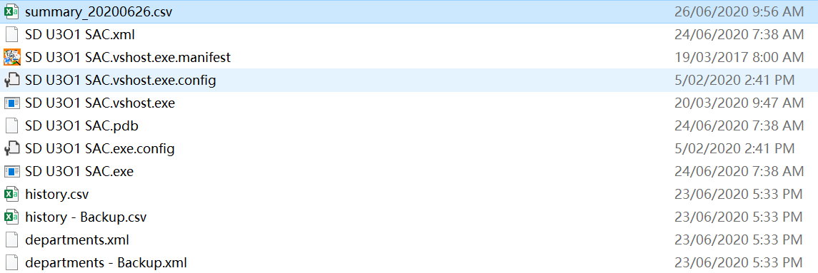 | No fix needed
3 | btnHome | Click | The interface switches to the main menu. | 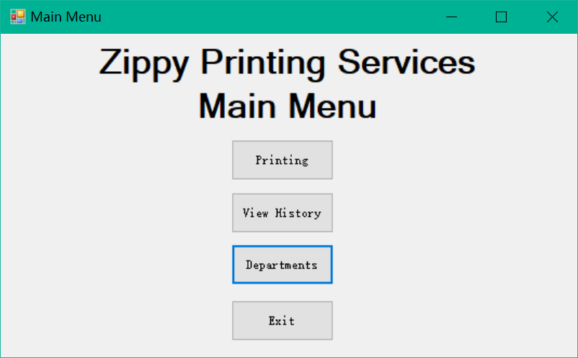 | No fix needed
4 | btnPrinting | Click | The interface switches to the form for printing stuff. | 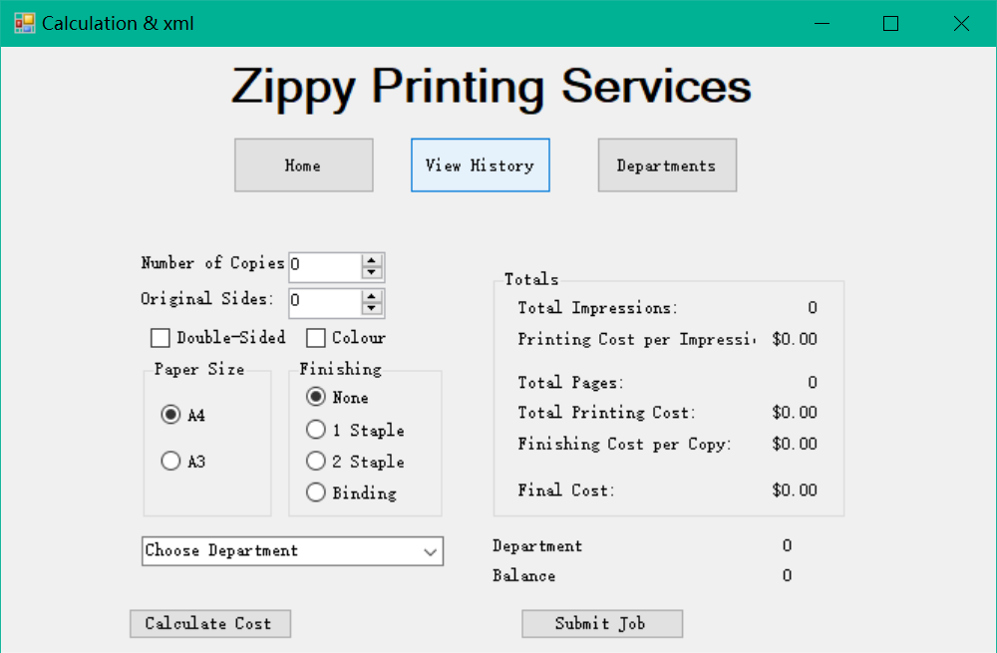 | No fix needed
5 | btnHistory | Click | The interface switches to the form for history checking. | 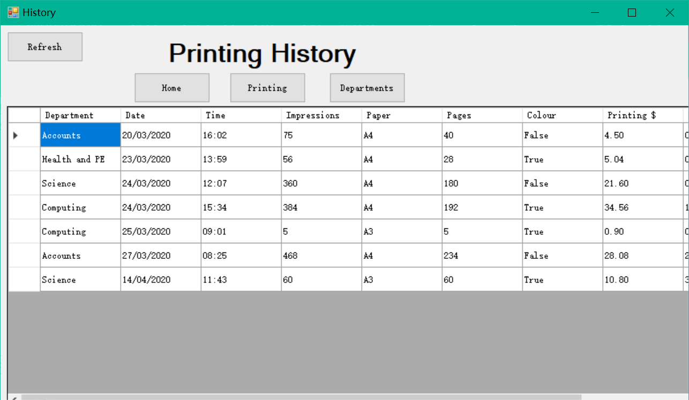 | No fix needed
6 | btnDepartment | Click | The interface switches to the form for department summary. | 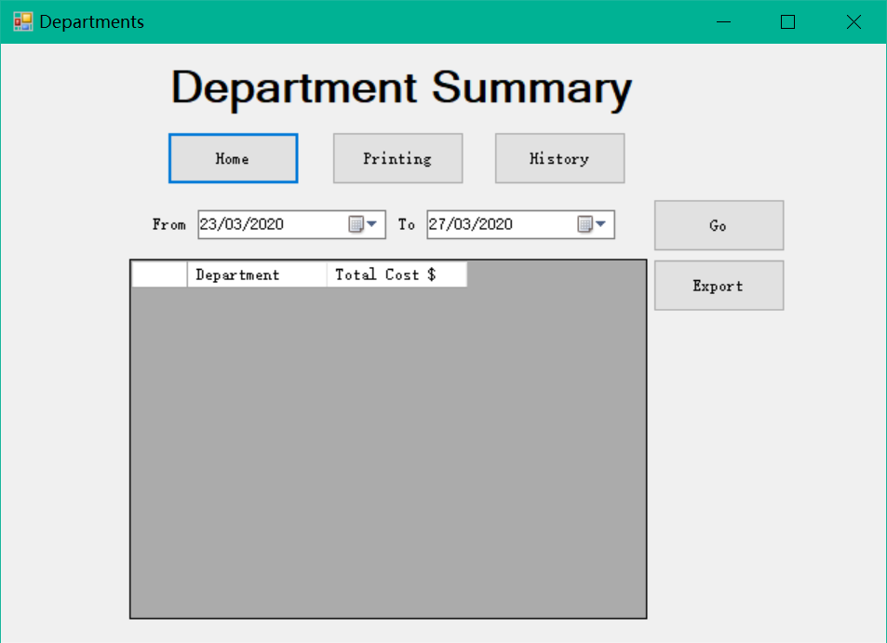 | No fix needed
7 | dtpFrom | Click on the icon of calendar | A month calendar displayed for picking a new date | 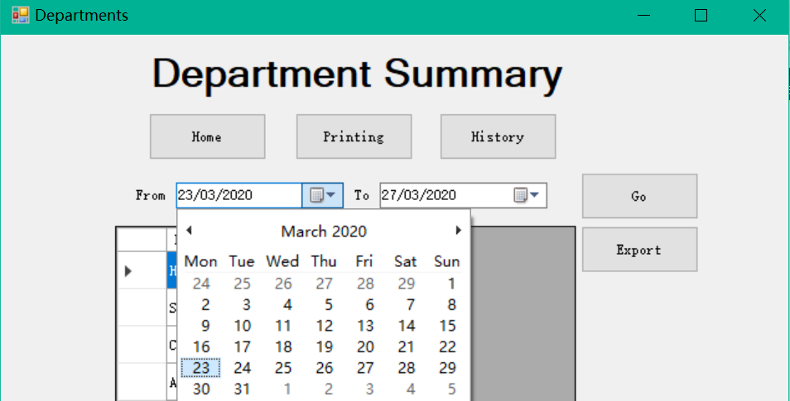 | No fix needed
8 | dtpTo | Click on the icon of calendar | A month calendar displayed for picking a new date | 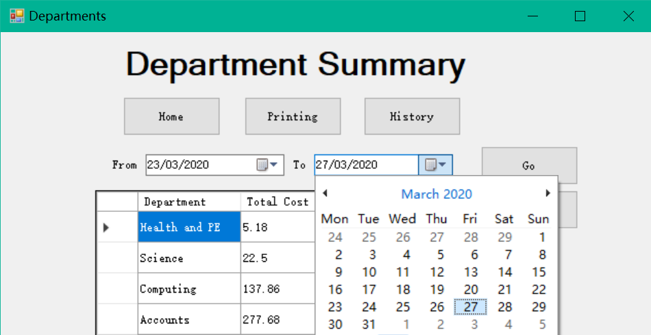 | No fix needed
9 | btnGo,  calculating the cost | Change the value of dtpFrom to 20/03/2020;  Change the value of dtpTo to 14/04/2020.  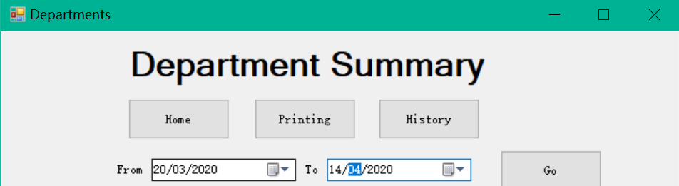  Click | Comparing to the input data for Test 2: Accounts’ cost should increase by 4.6 to 282.68.  Science’s cost should increase by 49.2 to 71.7.  Other departments’ costs should remain the same.  The order should be also the same. 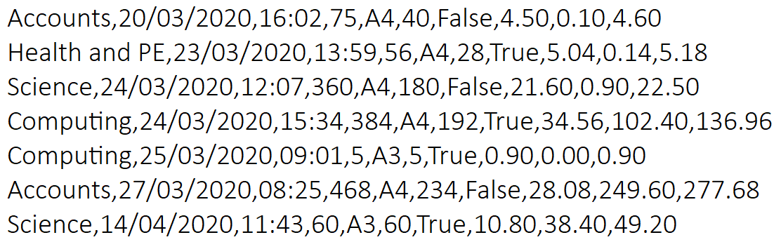 | 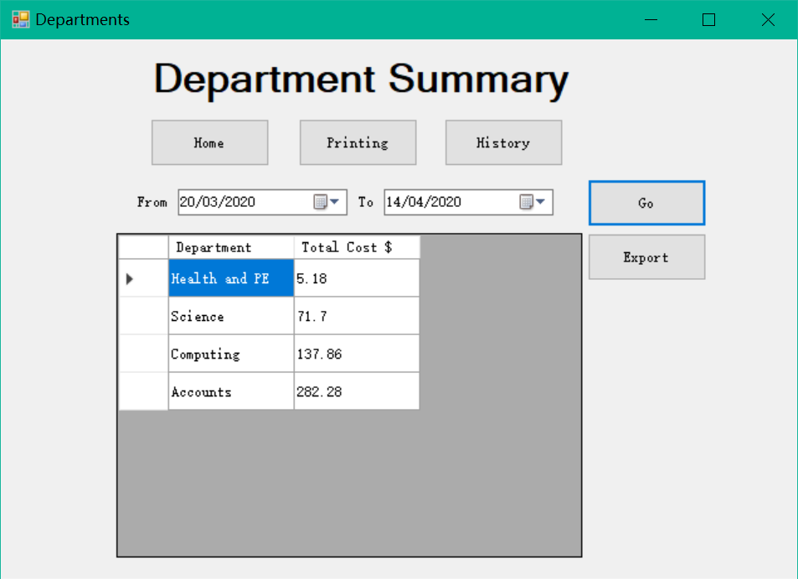 | No fix needed
10 | btnExport | Click | A new csv file should overwrite the previous one with updated displayed data shown in the DataGridView. The name of the file should be the same. | 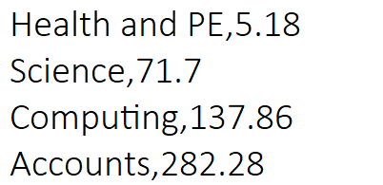  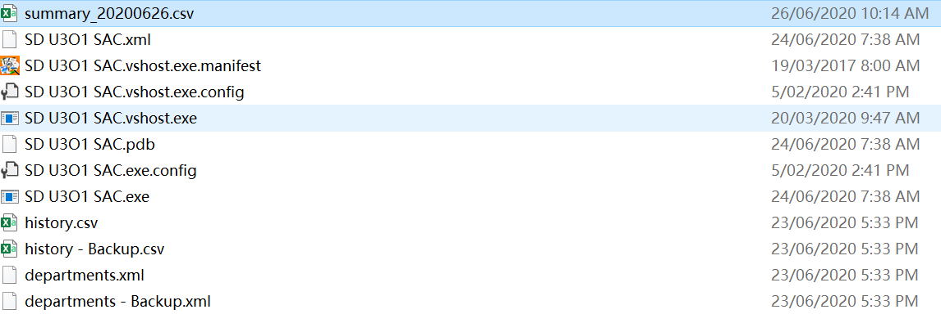 | No fix needed
11 | btnGo | 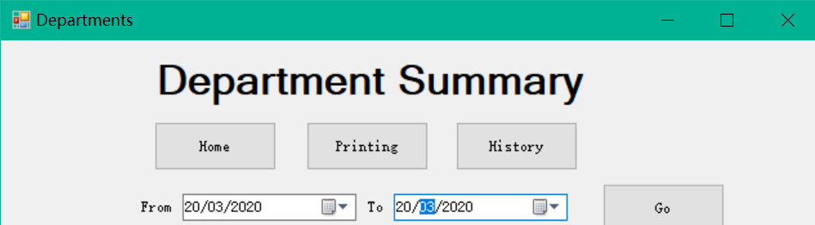 | Only Accounts has positive cost because only it has the record on the day. Other departments’ costs are 0. | 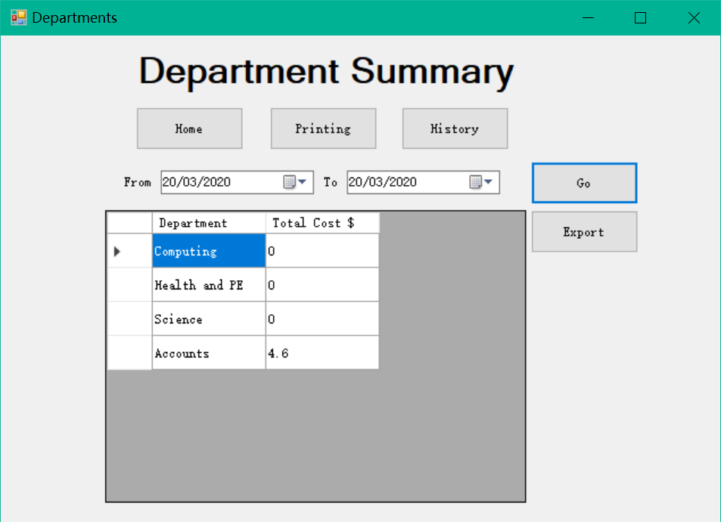 | No fix needed

